LAB 9

NAME: Aditya Anand

ROLL NO.: 20124009

BRANCH: IT

|  |  |  |  |
| --- | --- | --- | --- |
| S No. | Title | Date Of Implementation | Remarks |
| 1 | Program to illustrate MouseAdapter Class | 07-03-2021 |  |
| 2 | Program to illustrate KeyAdapter Class | 07-03-2021 |  |

Program to illustrate MouseAdapter Class

OBJECTIVE:

The following program creates a UI and overrides the mouseClicked method of the MouseAdapter Class.

The program creates a rectangle whenever a user makes a mouse click.

CODE:

import java.awt.*;

import java.awt.event.*;

public class Lab9MouseAdapter {

    public class MouseAdapterProg extends MouseAdapter{

        Frame f;

        MouseAdapterProg(){

            f = new Frame ("Mouse Adapter");

            f.addMouseListener(this);

            f.setSize (300, 300);

            f.setLayout (null);

            f.setVisible (true);

        }

        public void mouseClicked (MouseEvent e) {

            Graphics g = f.getGraphics();

            g.setColor (Color.BLUE);

            g.fillRect (e.getX(), e.getY(), 30, 30);

        }

    }

    public static void main(String[] args) {

        Lab9MouseAdapter l = new Lab9MouseAdapter();

        MouseAdapterProg m = l.new MouseAdapterProg();

    }

}

OUTPUT:

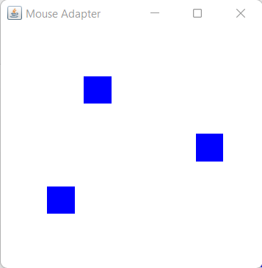

Program to illustrate MouseAdapter Class

OBJECTIVE:

The following program creates a UI and overrides the keyReleased method of the KeyAdapter Class.

The program counts the number of words and letters typed by the user.

CODE:

import java.awt.*;

import java.awt.event.*;

public class Lab9KeyAdapter {

    public class KeyAdapterProg extends KeyAdapter{

        Label l;

        TextArea area;

        Frame f;

        KeyAdapterProg(){

            f = new Frame ("Key Adapter");

            l = new Label();

            l.setBounds (20, 50, 200, 20);

            area = new TextArea();

            area.setBounds (20, 80, 300, 300);

            area.addKeyListener(this);

            f.add(l);

            f.add(area);

            f.setSize (400, 400);

            f.setLayout (null);

            f.setVisible (true);

        }

        public void keyReleased (KeyEvent e) {

            String text = area.getText();

            String words[] = text.split ("\\s");

            l.setText ("Words: " + words.length + " Characters:" + text.length());

        }

    }

    public static void main(String[] args) {

        Lab9KeyAdapter l = new Lab9KeyAdapter();

        KeyAdapterProg m = l.new KeyAdapterProg();

    }

}

OUTPUT:

